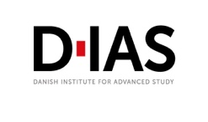
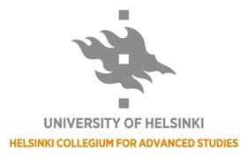
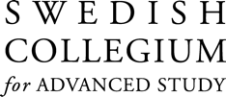
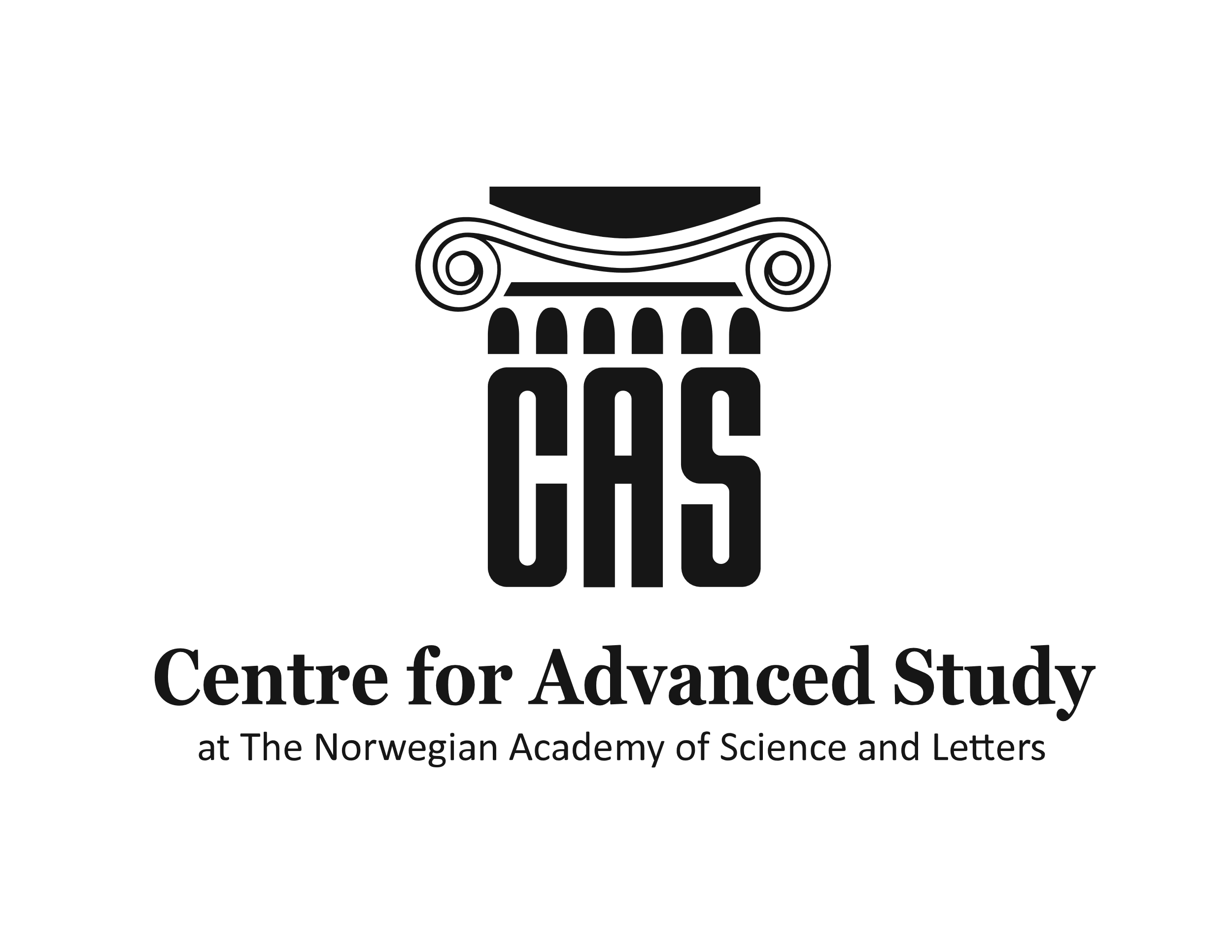
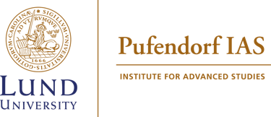
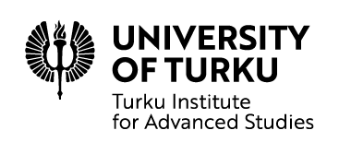

NordIAS
Visiting Fellowship Programme
____________________
Template for applications
Name of applicant
Current institute
Fellowship period at current institute
Research field and project title (please submit your CV in addition to the completed template)
Desired institute to visit (please prioritize up to three institutes)  It is up to the sending institute if one fellow can be granted more than one visit | - CAS, Oslo (not included in this call)  - SCAS, Uppsala  - Pufendorf, Lund  - HCAS, Helsinki  - TIAS, Turku  - Tampere IAS, Tampere  - DIAS, Odense  - AIAS, Aarhus
Desired dates and length of visit (1-3 weeks, between Feb 15 – June 30, 2024)
Potential collaborators at receiving institute(s)
Purpose of visit (max 500 words)
Your expected contribution to the visiting institute (conference, seminar presentation or other contribution)
Other relevant information/comment
Please submit the completed template and your CV (max 2 pages) to your current institute no later than Wednesday January 10, 2024.

